**JUE-60GX Operation Check List**

Carry out the following final checks for installation/maintenance of Inmarsat JUE-60GX.

Ship’s Name

Serial No. ADE:GV BDE:GV

Manufacture Date

Table 1　Operation check list

|  |  |  |  |  |  |  |
| --- | --- | --- | --- | --- | --- | --- |
| Checking item | |  | Checking contents | | | Check |
| 1 | Before  power ON | ADE-BDE cables  (RX cable, TX cable) | Coaxial cables between ADE and BDE is connected properly. No looseness or damage and waterproof to the connectors is found. To make waterproof to the connectors | | | □ |
| Cable connected to the rear side of BDE | The power cable is connected to a AC source of 100-200VAC. | | | □ |
| The cable for Ethernet port is properly connected. No looseness or damage to the connectors is found. | | | □ |
| The GYRO cable is properly connected. No looseness or damage to the connectors is found. | | | □ |
| 2 | Power ON | Initialize | READY LED is illuminated to Green.  It will take about 10 minutes after power on. | | | □ |
| Connect PC to MGM port. Start the browser and input the following URL. "http//192.168.1.2:9443".  Username: TECH, Password: 000001 | | | □ |
| Signal Level | Confirm that the signal level is at least 5 bars. A lower signal may result in non operation or drop the data sessions. | | | □ |
| ACU Status | NET, TX, RX1, STS, CM PWR, READY, ANT, STS1, STS2, STS3, STS4 are indicated to Green.  RX2 is indicated to Amber. | | | □ |
| 3 | Unit information | Version  JUE-60GX WEB  Logs->Alarm Pack | BDE | AIM | BIM | □ |
| Main App: |  |  |
| Sub App |  |  |
| Alarm  JUE-60GX WEB  Dashboard →Status | No alarm is displayed in Alarm information. | | | □ |
| Core Module (SCM) | Start the browser and open Core Module screen.  Refer the service manual for IP address, user name and password for Core Module. | | | □ |
| Network status is “In Network”. | | | □ |
| Serial Number |  | | □ |
| Software Version |  | | □ |
| Provisioning Key |  | | □ |
| 4 | GYRO Signal | Properly | Heading of JUE-60GX properly follows GYRO. | | | □ |
| Type of signal input to GYRO INTF ? |  | | | □ |
| Manufacturer of MASTER GYRO ? |  | | | □ |
| Model name of MASTER GYRO ? |  | | | □ |

Table 2. Setting contents record list

|  |  |  |
| --- | --- | --- |
| Setting item | Setting contents | |
| Terminal | Delivery Date | / / |
| Bow (Deg) |  |
| GYRO Input | NMEA(38.4k) / NMEA(4.8k) / Disable |
| GPS Input | NMEA(38.4k) / NMEA(4.8k) / Disable |
| VDR Output | LAN |
| Panel LED | On / Off |
| Ethernet LED | On / Off |

Table 3. LAN setting record list

|  |  |  |  |
| --- | --- | --- | --- |
| Setting item | | Setting contents | |
| JRC LAN Setting | EXT LAN | Type | JRC LAN / NSD LAN |
| Local VLAN ID |  |
| AIM | IP | ． ． ． |
| BIM | IP | ． ． ． |
| AIM / BIM | Subnet Mask | ． ． ． |

**Blockage Area**

Table 4．TX limit & Blockage

|  |  |  |  |  |  |
| --- | --- | --- | --- | --- | --- |
| NO. | function | EL Max | EL Min | BR Begin | BR End |
| 1 |  |  |  |  |  |
| 2 |  |  |  |  |  |
| 3 |  |  |  |  |  |
| 4 |  |  |  |  |  |
| 5 |  |  |  |  |  |
| 6 |  |  |  |  |  |
| 7 |  |  |  |  |  |
| 8 |  |  |  |  |  |
| 9 |  |  |  |  |  |
| 10 |  |  |  |  |  |

Fig.1 Blocking Chart (Fill out, if possible)

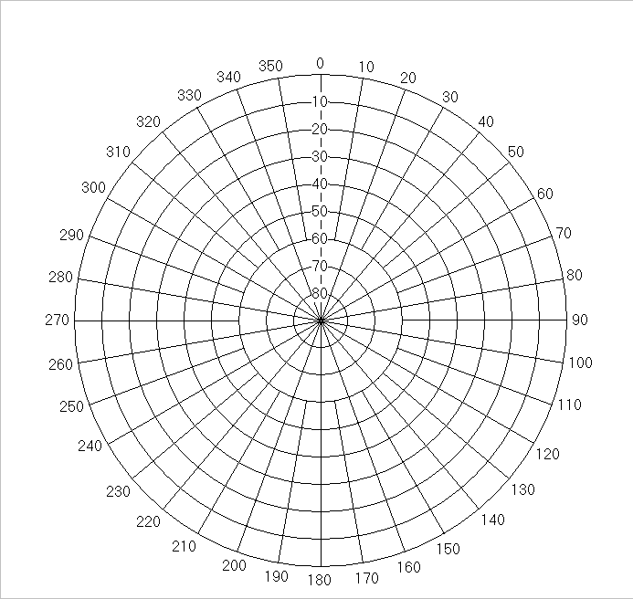

Fig. 2

Antenna installation

location

Top view

Side view

Fig. 1

Blocking Chart

(Fill out, if possible)

**Submit the configuration file:**

Submit the exported setting file (JUE-60GX WEB Tools→Export / Import→Export) to JRC Tokyo.

**Registration:**

Report to JRC Tokyo for your GX terminal warranty services.

**Remarks:**

Service Port

Installation Date

Agent

Signature